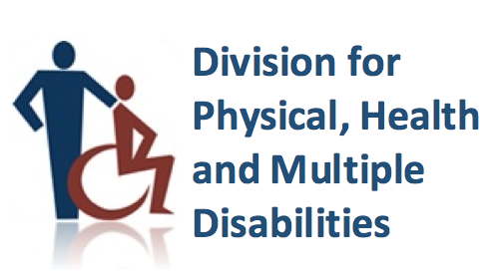

Quick Tip Sheet for Supporting Students who have

Inflammatory Bowel Disease

General Overview:
Inflammatory bowel disease (IBD) is swelling and irritation in the digestive tract which includes the mouth, esophagus, stomach, small intestine, large intestine, and rectum. The two most common types of IBD are Crohn’s disease and ulcerative colitis. Children with IBD may experience a wide range of symptoms which are listed below. IBD does not prevent students from participating in school but might result in increased absences, distractions, and tiredness while in school. Despite painful and distracting symptoms, students with IBD are generally able to participate in school and achieve academic success. To ensure academic success, accommodations can be made to help students cope with IBD. Below, you will find common effects (physical, emotional, and learning) and accommodations to support the effects.

Physical Side Effects:
- Fatigue
- Diarrhea
- Loss of appetite and weight loss
- Additional pain and intense cramping (can occur without warning)
- Urgent need to use the restroom
- Joint pain and some individuals experience chronic pain
- Skin rashes or acne

Emotional Side Effects:
- Reactions to illness may include: denial, grief, and embarrassment
- May act younger or more immature than peers
- Increased risk for depression, anxiety, and low self-esteem
- Fluctuations in mood

Learning Effects:

Decreased concentration (due to fatigue and pain)
- Poor academic performance (due to absences and fatigue)
- Inability to keep up with demands of classroom setting

Accommodations to Meet Learning Needs:
- Unlimited access to restroom (without questioning)
- Access to single/faculty restrooms
- Preferential seating near exit of classroom
- Access to snacks and fluids throughout the school day
- Frequent breaks during testing
- Reduced workload (as needed)
- Extended time on tests, quizzes, and assignments
- Access to an extra set of clothing at school
- Access to reteaching and/or tutoring for missed instruction
- Access to homebound instruction for extended absences

